

Database Management Lab File (ENCS205)

Bachelor of Technology in
Computer Science and Engineering

B. Tech CSE (Core) 4 Semester

School of Engineering & Technology

K. R. MANGALAM UNIVERSITY Sohna, Haryana 122103, India Jan-2026

Submitted By: | Submitted To:
Vanshika Dubey (2401010067) | MS. Mansi Kajal

EXPERIMENT-1
Consider following Company databases and draw ER diagram and convert entities and relationships to relation table for a given scenario:
EMPLOYEE (SSN, Name, Address, Sex, Salary, Super SSN, D No.) DEPARTMENT (D No., D Name, Mgr SSN, Mgr Start Date) DLOCATION (D Location)
PROJECT (P No., P Name, P Location, D No.) WORKING (SSN, P No., Hours Worked)
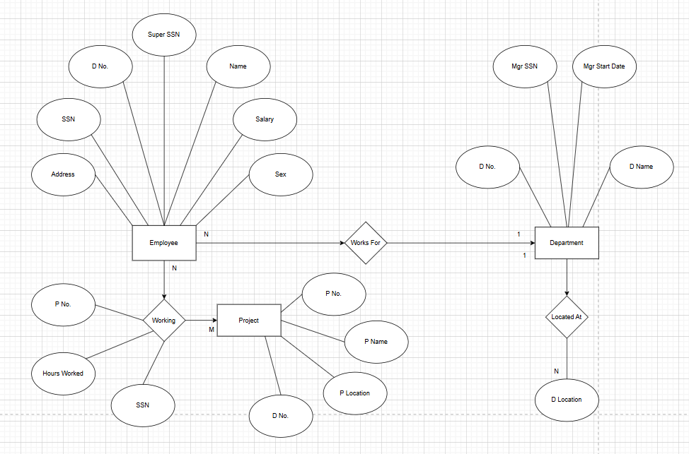

• The Company Database ER diagram represents the organizational structure of a company. It stores information about employees, departments, projects, and work assignments.
• The main entity is Employee, which contains details of all employees working in the company.
• The attributes include SSN, Name, Address, Sex, Salary, SuperSSN, and DNo.
– SSN uniquely identifies each employee.
– Therefore, SSN is the primary key.
• SuperSSN refers to the supervisor of an employee.
– This creates a recursive relationship where an employee can supervise other employees.
• DNo connects the employee to a department and acts as a foreign key.
• The Department entity stores department information.
• Its attributes include DNo, DName, MgrSSN, and MgrStartDate.
– DNo uniquely identifies each department.
– Hence, it is the primary key.
• MgrSSN represents the manager of the department and references the Employee entity.
• The Works For relationship connects Employee and Department.
– One department can have many employees.
– Each employee works for only one department.
– Therefore, it is a one-to-many relationship.
• The Project entity stores project details handled by departments.
• Its attributes include PNo, PName, PLocation, and DNo.
– PNo uniquely identifies each project and is the primary key.
– DNo links the project to a department.
• The Works_On relationship connects Employee and Project.
• It includes SSN, PNo, and Hours.
– Hours shows the number of hours worked on a project.
– Since many employees can work on many projects, this is a many-to-many relationship.
– Hence, Works_On becomes an associative relation with a composite primary key.
• The DLocation entity stores the locations of departments.
• Its attributes are DNo and DLoc.
– A department may have multiple locations.
– Therefore, this forms a one-to-many relationship.
• This ER model ensures proper organization of company data, avoids duplication, and maintains integrity between related tables.
• It helps management track employees, projects, departments, and working hours efficiently.

EXPERIMENT-2
Consider following College databases and draw ER diagram and convert entities and relationships to relation table for a given scenario:
STUDENT (USN, S Name, Address, Phone, Gender)
SEMSEC (SSID, Sem, SEC)
CLASS (USN, SSID)
SUBJECT (Code, Name, Sem, Credits)
IAMARKS (Test1, Test2, Test3, FinalIA)
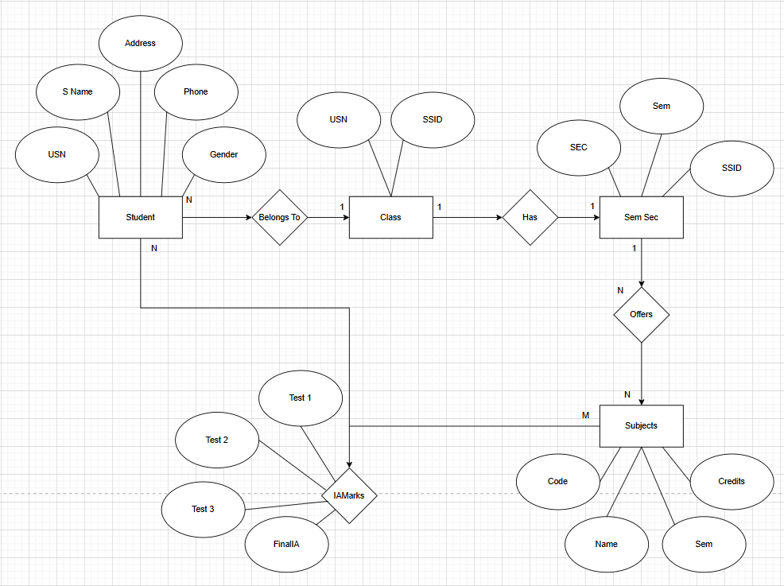

• The College Database ER diagram represents the structure of student academic information stored in a college management system. It shows how students, classes, subjects, and marks are related to each other.
• The main entity in the system is Student. It stores personal and academic details of every student enrolled in the college.
• The attributes of Student include USN, SName, Address, Phone, and Gender.
– USN (University Seat Number) uniquely identifies each student.
– Therefore, USN is considered the primary key.
• The next entity is SemSec (Semester Section). It represents the semester and section in which students are placed.
• The attributes of SemSec are SSID, Sem, and Sec.
– SSID uniquely identifies each semester-section combination.
– Hence, SSID acts as the primary key.
• The Class entity connects Student and SemSec. It shows which student belongs to which semester and section.
• Class contains the attributes USN and SSID.
– These are foreign keys referencing Student and SemSec.
– Together they form a composite primary key.
– This relationship is many-to-one, where many students belong to one semester-section.
• Another entity is Subject, which stores subject details offered in each semester.
• Its attributes are Subcode, Title, Sem, and Credits.
– Subcode uniquely identifies each subject.
– Therefore, Subcode is the primary key.
• There is an Offers relationship between SemSec and Subject.
– This indicates that each semester-section offers multiple subjects.
– This is a one-to-many relationship.
• The IAMarks entity stores internal assessment marks of students.
• It includes USN, Subcode, SSID, Test1, Test2, Test3, and FinalIA.
– Test1, Test2, Test3, and FinalIA represent marks obtained in tests.
– USN, Subcode, and SSID together uniquely identify each record.
– Hence, they form a composite primary key.
• IAMarks resolves the many-to-many relationship between students and subjects because each student has marks for many subjects and each subject has marks for many students.
• This ER model reduces data redundancy and maintains consistency by separating student, subject, and marks data.
• The design improves efficiency, easy updates, and proper management of academic records.

EXPERMINT-3
Database Schema for a customer-sale scenario
Customer(Cust id : integer, cust_name: string)
Item(item_id: integer, item_name: string, price: integer)
Sale(bill_no:integer,bill_data:date,cust_id: integer, item_id: integer, qty_sold: integer)
For the above schema, perform the following-
- Create the tables with the appropriate integrity constraints.
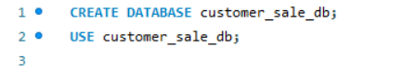
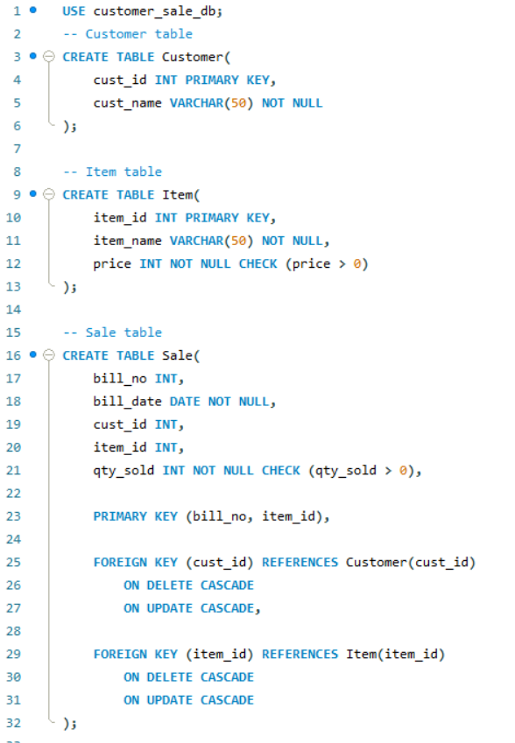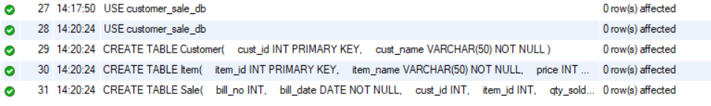
- Insert around 10 records in each of the tables. 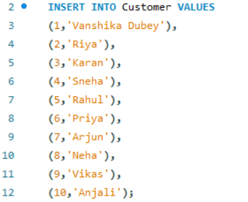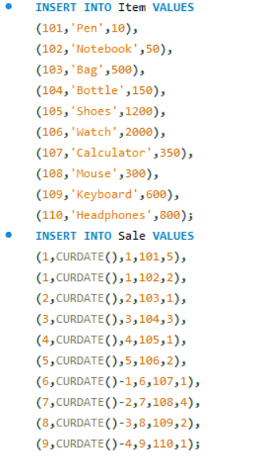

- List all the bills for the current date with the customer names and item numbers. 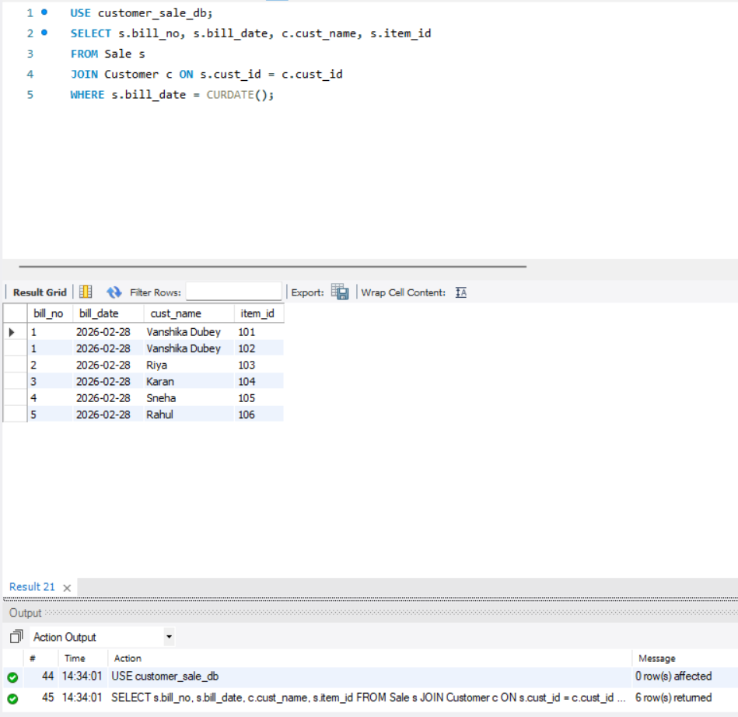

- List the total Bill details with the quantity sold, price of the item and the final amount. 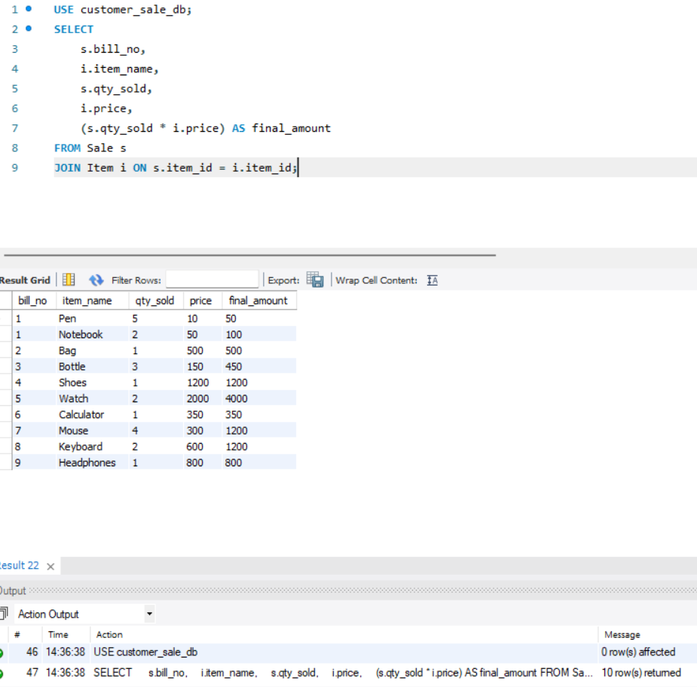

- List the details of the customer who have bought a product which has a price>200. 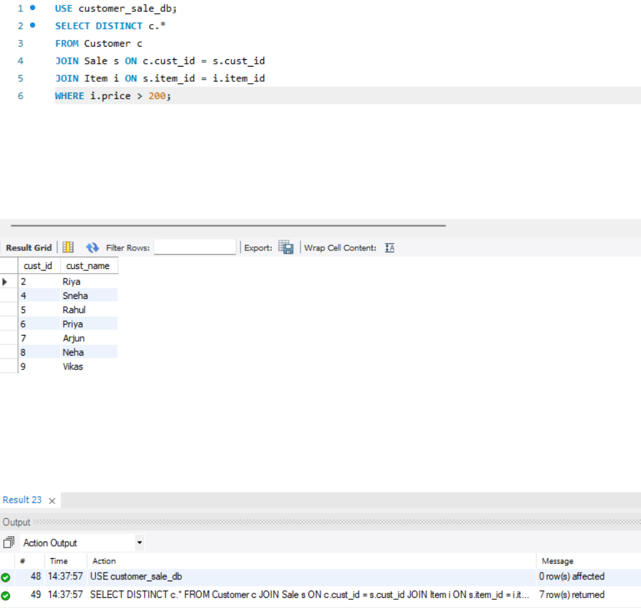
- Give a count of how many products have been bought by each customer. 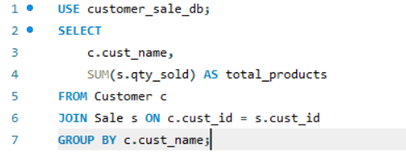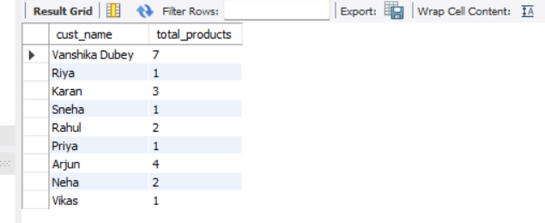

- Give a list of products bought by a customer having cust_id as 5.
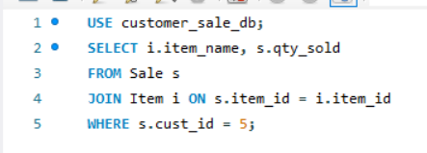
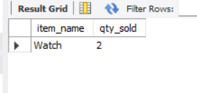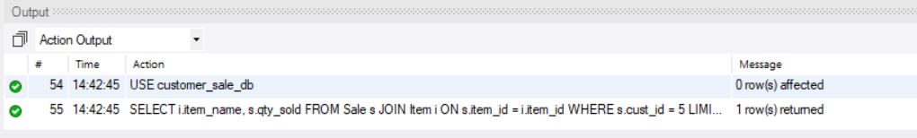
- List the item details which are sold as of today. 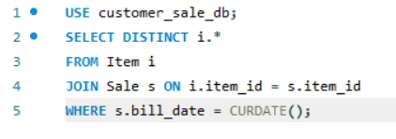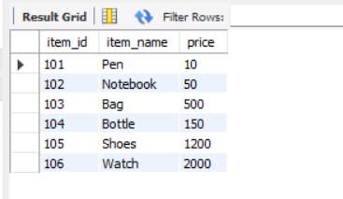
- Create a view which lists out the bill_no, bill_date, cust_id, item_id, price, qty_sold, amount

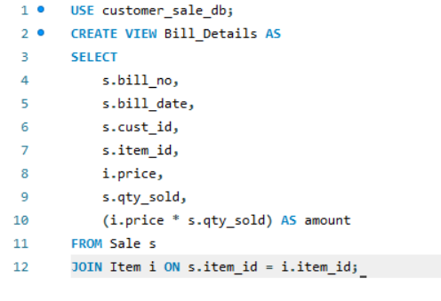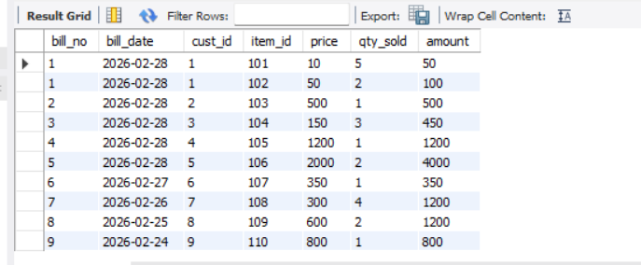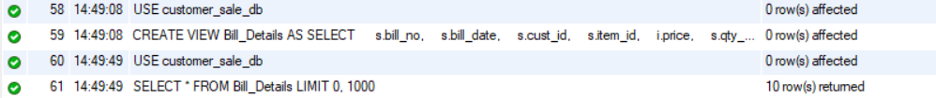
- Create a view which lists the daily sales date wise for the last one week.
